VH_Visualization

Abhishek Suragani

01/12/2021

library(tidyverse)

## -- Attaching packages --------------------------------------- tidyverse 1.3.1 --

## v ggplot2 3.3.5 v purrr 0.3.4  
## v tibble 3.1.5 v dplyr 1.0.7  
## v tidyr 1.1.4 v stringr 1.4.0  
## v readr 2.0.2 v forcats 0.5.1

## -- Conflicts ------------------------------------------ tidyverse_conflicts() --  
## x dplyr::filter() masks stats::filter()  
## x dplyr::lag() masks stats::lag()

library(reshape2)

##   
## Attaching package: 'reshape2'

## The following object is masked from 'package:tidyr':  
##   
## smiths

Quantitative: Use a histogram

* Categorical: Use a bar chart. Or just a table of *proportions* (table() then prop.table()).
* Quantitative vs Quantitative: Use a scatterplot
* Categorical vs Quantitative: Use a boxplot
* Categorical vs Categorical: Use a mosaic plot or a count plot

#1. #Based on regions what is the proportion of people that are vaccine hesitant ?

df3 <- read.csv("df3.csv")  
  
df3%>%  
 group_by(Region)%>%  
 summarise(Average_Estimated.hesitant = mean(Estimated.hesitant + Estimated.strongly.hesitant))%>%  
 ggplot(aes(x = Region, y = Average_Estimated.hesitant)) +   
 geom_col(aes(fill = Region)) + theme_bw() +  
 ggtitle("Mean Estimated Hesitant Rate as per Region") +  
 theme(plot.title = element_text(hjust = 0.5))

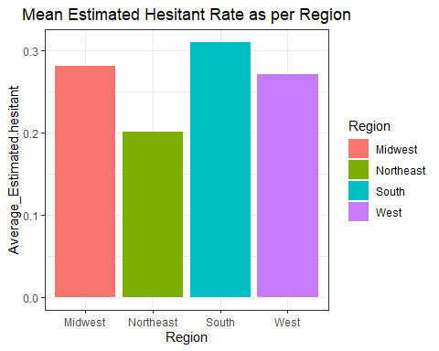

#2. SVI Category vs estimated Hesitant

#boxplot -  
  
#df3 %>%mutate(SVI.Category = as.factor(SVI.Category, levels = c("Very Low Concern", "Low Concern", "Moderate Concern", "High Concern", "Very High Concern")) %>%  
   
ggplot(df3, aes(x = SVI.Category, y = Estimated.hesitant, fill = SVI.Category)) +   
 geom_boxplot() + theme_bw()

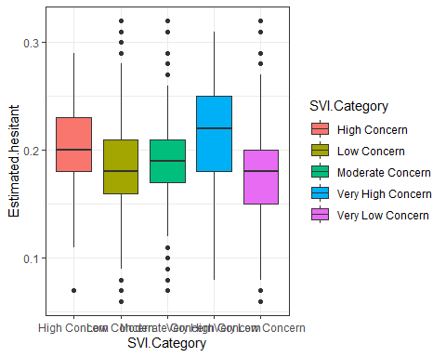

# we can add region but it seems hard to explain

#Estimated Hesitancy vs Dia(Quant vs Quant)

ggplot(df3, aes( x = Diabetes_Percent,   
 y = Estimated.hesitant, color = Diabetes_Percent > 10)) + geom_point() + geom_smooth(fill = NA) + expand_limits(y=0) +  
 theme_bw()

## `geom_smooth()` using method = 'gam' and formula 'y ~ s(x, bs = "cs")'

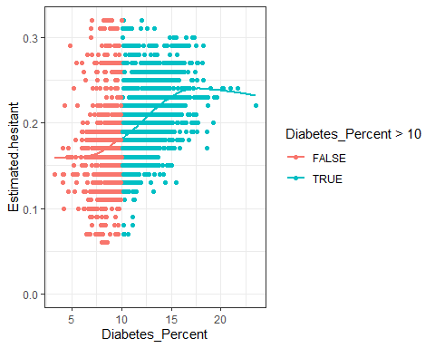

#Given a condition as it will help while explaining project that Diabetes Percent is directly proportiinal to Estimated Hesitancy

#Estimated Hesitant based on Party

df3 %>%  
 rename(Republican = "party_REPUBLICAN",   
 Democratic = "party_DEMOCRAT" ) %>%  
 pivot_longer(c(Democratic, Republican), names_to = "Party", values_to = "Majority") -> df9  
colnames(df3)

## [1] "X"   
## [2] "FIPS"   
## [3] "County.Name"   
## [4] "State.Name"   
## [5] "State.Code"   
## [6] "Region"   
## [7] "Estimated.hesitant"   
## [8] "Estimated.strongly.hesitant"   
## [9] "SVI"   
## [10] "SVI.Category"   
## [11] "CVAC.level.of.concern.for.vaccination.rollout"   
## [12] "CVAC.Level.Of.Concern"   
## [13] "Percent.Hispanic"   
## [14] "Percent.non.Hispanic.American.Indian.Alaska.Native"   
## [15] "Percent.non.Hispanic.Asian"   
## [16] "Percent.non.Hispanic.Black"   
## [17] "Percent.non.Hispanic.Native.Hawaiian.Pacific.Islander"  
## [18] "Percent.non.Hispanic.White"   
## [19] "Median_Household_Income_2019"   
## [20] "Region_Midwest"   
## [21] "Region_Northeast"   
## [22] "Region_South"   
## [23] "Region_West"   
## [24] "Diabetes_Percent"   
## [25] "Obesity_Percent"   
## [26] "unemployment_rate"   
## [27] "party_DEMOCRAT"   
## [28] "party_REPUBLICAN"

ggplot(df9, aes(x= Party, y = Majority, color = Party)) +   
 geom_col() + facet_wrap(~ Estimated.hesitant) +  
 theme_bw()

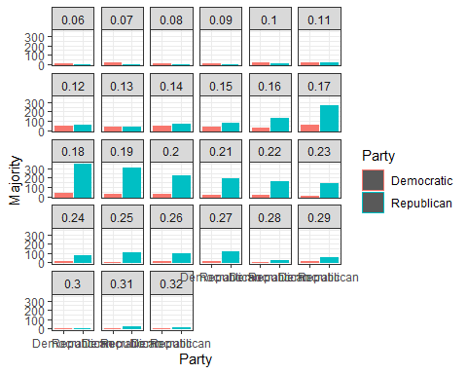

# Estimated hesitancy based on Race

colnames(df3)

## [1] "X"   
## [2] "FIPS"   
## [3] "County.Name"   
## [4] "State.Name"   
## [5] "State.Code"   
## [6] "Region"   
## [7] "Estimated.hesitant"   
## [8] "Estimated.strongly.hesitant"   
## [9] "SVI"   
## [10] "SVI.Category"   
## [11] "CVAC.level.of.concern.for.vaccination.rollout"   
## [12] "CVAC.Level.Of.Concern"   
## [13] "Percent.Hispanic"   
## [14] "Percent.non.Hispanic.American.Indian.Alaska.Native"   
## [15] "Percent.non.Hispanic.Asian"   
## [16] "Percent.non.Hispanic.Black"   
## [17] "Percent.non.Hispanic.Native.Hawaiian.Pacific.Islander"  
## [18] "Percent.non.Hispanic.White"   
## [19] "Median_Household_Income_2019"   
## [20] "Region_Midwest"   
## [21] "Region_Northeast"   
## [22] "Region_South"   
## [23] "Region_West"   
## [24] "Diabetes_Percent"   
## [25] "Obesity_Percent"   
## [26] "unemployment_rate"   
## [27] "party_DEMOCRAT"   
## [28] "party_REPUBLICAN"

df3 %>%   
 rename(Hispanic = "Percent.Hispanic",  
 American_Indian_Alaska_Native = "Percent.non.Hispanic.American.Indian.Alaska.Native",  
 Asian = "Percent.non.Hispanic.Asian",  
 Black = "Percent.non.Hispanic.Black",  
 Hawaiian_Pacific_Islander = "Percent.non.Hispanic.Native.Hawaiian.Pacific.Islander",   
 White = "Percent.non.Hispanic.White") %>%  
 pivot_longer(c(Hispanic,American_Indian_Alaska_Native,  
 Asian, Black, Hawaiian_Pacific_Islander, White),   
 names_to = "Race",values_to = "Percent") -> df7

ggplot(df7, aes(x = Percent, y = Estimated.hesitant)) +  
 geom_point(aes(color = Race)) + facet_wrap(~ Race)

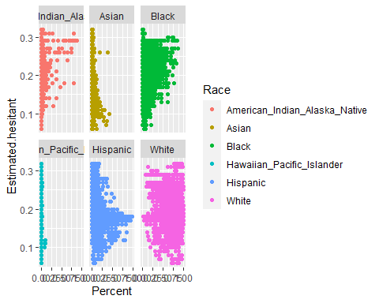

theme_bw()

## List of 93  
## $ line :List of 6  
## ..$ colour : chr "black"  
## ..$ size : num 0.5  
## ..$ linetype : num 1  
## ..$ lineend : chr "butt"  
## ..$ arrow : logi FALSE  
## ..$ inherit.blank: logi TRUE  
## ..- attr(*, "class")= chr [1:2] "element_line" "element"  
## $ rect :List of 5  
## ..$ fill : chr "white"  
## ..$ colour : chr "black"  
## ..$ size : num 0.5  
## ..$ linetype : num 1  
## ..$ inherit.blank: logi TRUE  
## ..- attr(*, "class")= chr [1:2] "element_rect" "element"  
## $ text :List of 11  
## ..$ family : chr ""  
## ..$ face : chr "plain"  
## ..$ colour : chr "black"  
## ..$ size : num 11  
## ..$ hjust : num 0.5  
## ..$ vjust : num 0.5  
## ..$ angle : num 0  
## ..$ lineheight : num 0.9  
## ..$ margin : 'margin' num [1:4] 0points 0points 0points 0points  
## .. ..- attr(*, "unit")= int 8  
## ..$ debug : logi FALSE  
## ..$ inherit.blank: logi TRUE  
## ..- attr(*, "class")= chr [1:2] "element_text" "element"  
## $ title : NULL  
## $ aspect.ratio : NULL  
## $ axis.title : NULL  
## $ axis.title.x :List of 11  
## ..$ family : NULL  
## ..$ face : NULL  
## ..$ colour : NULL  
## ..$ size : NULL  
## ..$ hjust : NULL  
## ..$ vjust : num 1  
## ..$ angle : NULL  
## ..$ lineheight : NULL  
## ..$ margin : 'margin' num [1:4] 2.75points 0points 0points 0points  
## .. ..- attr(*, "unit")= int 8  
## ..$ debug : NULL  
## ..$ inherit.blank: logi TRUE  
## ..- attr(*, "class")= chr [1:2] "element_text" "element"  
## $ axis.title.x.top :List of 11  
## ..$ family : NULL  
## ..$ face : NULL  
## ..$ colour : NULL  
## ..$ size : NULL  
## ..$ hjust : NULL  
## ..$ vjust : num 0  
## ..$ angle : NULL  
## ..$ lineheight : NULL  
## ..$ margin : 'margin' num [1:4] 0points 0points 2.75points 0points  
## .. ..- attr(*, "unit")= int 8  
## ..$ debug : NULL  
## ..$ inherit.blank: logi TRUE  
## ..- attr(*, "class")= chr [1:2] "element_text" "element"  
## $ axis.title.x.bottom : NULL  
## $ axis.title.y :List of 11  
## ..$ family : NULL  
## ..$ face : NULL  
## ..$ colour : NULL  
## ..$ size : NULL  
## ..$ hjust : NULL  
## ..$ vjust : num 1  
## ..$ angle : num 90  
## ..$ lineheight : NULL  
## ..$ margin : 'margin' num [1:4] 0points 2.75points 0points 0points  
## .. ..- attr(*, "unit")= int 8  
## ..$ debug : NULL  
## ..$ inherit.blank: logi TRUE  
## ..- attr(*, "class")= chr [1:2] "element_text" "element"  
## $ axis.title.y.left : NULL  
## $ axis.title.y.right :List of 11  
## ..$ family : NULL  
## ..$ face : NULL  
## ..$ colour : NULL  
## ..$ size : NULL  
## ..$ hjust : NULL  
## ..$ vjust : num 0  
## ..$ angle : num -90  
## ..$ lineheight : NULL  
## ..$ margin : 'margin' num [1:4] 0points 0points 0points 2.75points  
## .. ..- attr(*, "unit")= int 8  
## ..$ debug : NULL  
## ..$ inherit.blank: logi TRUE  
## ..- attr(*, "class")= chr [1:2] "element_text" "element"  
## $ axis.text :List of 11  
## ..$ family : NULL  
## ..$ face : NULL  
## ..$ colour : chr "grey30"  
## ..$ size : 'rel' num 0.8  
## ..$ hjust : NULL  
## ..$ vjust : NULL  
## ..$ angle : NULL  
## ..$ lineheight : NULL  
## ..$ margin : NULL  
## ..$ debug : NULL  
## ..$ inherit.blank: logi TRUE  
## ..- attr(*, "class")= chr [1:2] "element_text" "element"  
## $ axis.text.x :List of 11  
## ..$ family : NULL  
## ..$ face : NULL  
## ..$ colour : NULL  
## ..$ size : NULL  
## ..$ hjust : NULL  
## ..$ vjust : num 1  
## ..$ angle : NULL  
## ..$ lineheight : NULL  
## ..$ margin : 'margin' num [1:4] 2.2points 0points 0points 0points  
## .. ..- attr(*, "unit")= int 8  
## ..$ debug : NULL  
## ..$ inherit.blank: logi TRUE  
## ..- attr(*, "class")= chr [1:2] "element_text" "element"  
## $ axis.text.x.top :List of 11  
## ..$ family : NULL  
## ..$ face : NULL  
## ..$ colour : NULL  
## ..$ size : NULL  
## ..$ hjust : NULL  
## ..$ vjust : num 0  
## ..$ angle : NULL  
## ..$ lineheight : NULL  
## ..$ margin : 'margin' num [1:4] 0points 0points 2.2points 0points  
## .. ..- attr(*, "unit")= int 8  
## ..$ debug : NULL  
## ..$ inherit.blank: logi TRUE  
## ..- attr(*, "class")= chr [1:2] "element_text" "element"  
## $ axis.text.x.bottom : NULL  
## $ axis.text.y :List of 11  
## ..$ family : NULL  
## ..$ face : NULL  
## ..$ colour : NULL  
## ..$ size : NULL  
## ..$ hjust : num 1  
## ..$ vjust : NULL  
## ..$ angle : NULL  
## ..$ lineheight : NULL  
## ..$ margin : 'margin' num [1:4] 0points 2.2points 0points 0points  
## .. ..- attr(*, "unit")= int 8  
## ..$ debug : NULL  
## ..$ inherit.blank: logi TRUE  
## ..- attr(*, "class")= chr [1:2] "element_text" "element"  
## $ axis.text.y.left : NULL  
## $ axis.text.y.right :List of 11  
## ..$ family : NULL  
## ..$ face : NULL  
## ..$ colour : NULL  
## ..$ size : NULL  
## ..$ hjust : num 0  
## ..$ vjust : NULL  
## ..$ angle : NULL  
## ..$ lineheight : NULL  
## ..$ margin : 'margin' num [1:4] 0points 0points 0points 2.2points  
## .. ..- attr(*, "unit")= int 8  
## ..$ debug : NULL  
## ..$ inherit.blank: logi TRUE  
## ..- attr(*, "class")= chr [1:2] "element_text" "element"  
## $ axis.ticks :List of 6  
## ..$ colour : chr "grey20"  
## ..$ size : NULL  
## ..$ linetype : NULL  
## ..$ lineend : NULL  
## ..$ arrow : logi FALSE  
## ..$ inherit.blank: logi TRUE  
## ..- attr(*, "class")= chr [1:2] "element_line" "element"  
## $ axis.ticks.x : NULL  
## $ axis.ticks.x.top : NULL  
## $ axis.ticks.x.bottom : NULL  
## $ axis.ticks.y : NULL  
## $ axis.ticks.y.left : NULL  
## $ axis.ticks.y.right : NULL  
## $ axis.ticks.length : 'simpleUnit' num 2.75points  
## ..- attr(*, "unit")= int 8  
## $ axis.ticks.length.x : NULL  
## $ axis.ticks.length.x.top : NULL  
## $ axis.ticks.length.x.bottom: NULL  
## $ axis.ticks.length.y : NULL  
## $ axis.ticks.length.y.left : NULL  
## $ axis.ticks.length.y.right : NULL  
## $ axis.line : list()  
## ..- attr(*, "class")= chr [1:2] "element_blank" "element"  
## $ axis.line.x : NULL  
## $ axis.line.x.top : NULL  
## $ axis.line.x.bottom : NULL  
## $ axis.line.y : NULL  
## $ axis.line.y.left : NULL  
## $ axis.line.y.right : NULL  
## $ legend.background :List of 5  
## ..$ fill : NULL  
## ..$ colour : logi NA  
## ..$ size : NULL  
## ..$ linetype : NULL  
## ..$ inherit.blank: logi TRUE  
## ..- attr(*, "class")= chr [1:2] "element_rect" "element"  
## $ legend.margin : 'margin' num [1:4] 5.5points 5.5points 5.5points 5.5points  
## ..- attr(*, "unit")= int 8  
## $ legend.spacing : 'simpleUnit' num 11points  
## ..- attr(*, "unit")= int 8  
## $ legend.spacing.x : NULL  
## $ legend.spacing.y : NULL  
## $ legend.key :List of 5  
## ..$ fill : chr "white"  
## ..$ colour : logi NA  
## ..$ size : NULL  
## ..$ linetype : NULL  
## ..$ inherit.blank: logi TRUE  
## ..- attr(*, "class")= chr [1:2] "element_rect" "element"  
## $ legend.key.size : 'simpleUnit' num 1.2lines  
## ..- attr(*, "unit")= int 3  
## $ legend.key.height : NULL  
## $ legend.key.width : NULL  
## $ legend.text :List of 11  
## ..$ family : NULL  
## ..$ face : NULL  
## ..$ colour : NULL  
## ..$ size : 'rel' num 0.8  
## ..$ hjust : NULL  
## ..$ vjust : NULL  
## ..$ angle : NULL  
## ..$ lineheight : NULL  
## ..$ margin : NULL  
## ..$ debug : NULL  
## ..$ inherit.blank: logi TRUE  
## ..- attr(*, "class")= chr [1:2] "element_text" "element"  
## $ legend.text.align : NULL  
## $ legend.title :List of 11  
## ..$ family : NULL  
## ..$ face : NULL  
## ..$ colour : NULL  
## ..$ size : NULL  
## ..$ hjust : num 0  
## ..$ vjust : NULL  
## ..$ angle : NULL  
## ..$ lineheight : NULL  
## ..$ margin : NULL  
## ..$ debug : NULL  
## ..$ inherit.blank: logi TRUE  
## ..- attr(*, "class")= chr [1:2] "element_text" "element"  
## $ legend.title.align : NULL  
## $ legend.position : chr "right"  
## $ legend.direction : NULL  
## $ legend.justification : chr "center"  
## $ legend.box : NULL  
## $ legend.box.just : NULL  
## $ legend.box.margin : 'margin' num [1:4] 0cm 0cm 0cm 0cm  
## ..- attr(*, "unit")= int 1  
## $ legend.box.background : list()  
## ..- attr(*, "class")= chr [1:2] "element_blank" "element"  
## $ legend.box.spacing : 'simpleUnit' num 11points  
## ..- attr(*, "unit")= int 8  
## $ panel.background :List of 5  
## ..$ fill : chr "white"  
## ..$ colour : logi NA  
## ..$ size : NULL  
## ..$ linetype : NULL  
## ..$ inherit.blank: logi TRUE  
## ..- attr(*, "class")= chr [1:2] "element_rect" "element"  
## $ panel.border :List of 5  
## ..$ fill : logi NA  
## ..$ colour : chr "grey20"  
## ..$ size : NULL  
## ..$ linetype : NULL  
## ..$ inherit.blank: logi TRUE  
## ..- attr(*, "class")= chr [1:2] "element_rect" "element"  
## $ panel.spacing : 'simpleUnit' num 5.5points  
## ..- attr(*, "unit")= int 8  
## $ panel.spacing.x : NULL  
## $ panel.spacing.y : NULL  
## $ panel.grid :List of 6  
## ..$ colour : chr "grey92"  
## ..$ size : NULL  
## ..$ linetype : NULL  
## ..$ lineend : NULL  
## ..$ arrow : logi FALSE  
## ..$ inherit.blank: logi TRUE  
## ..- attr(*, "class")= chr [1:2] "element_line" "element"  
## $ panel.grid.major : NULL  
## $ panel.grid.minor :List of 6  
## ..$ colour : NULL  
## ..$ size : 'rel' num 0.5  
## ..$ linetype : NULL  
## ..$ lineend : NULL  
## ..$ arrow : logi FALSE  
## ..$ inherit.blank: logi TRUE  
## ..- attr(*, "class")= chr [1:2] "element_line" "element"  
## $ panel.grid.major.x : NULL  
## $ panel.grid.major.y : NULL  
## $ panel.grid.minor.x : NULL  
## $ panel.grid.minor.y : NULL  
## $ panel.ontop : logi FALSE  
## $ plot.background :List of 5  
## ..$ fill : NULL  
## ..$ colour : chr "white"  
## ..$ size : NULL  
## ..$ linetype : NULL  
## ..$ inherit.blank: logi TRUE  
## ..- attr(*, "class")= chr [1:2] "element_rect" "element"  
## $ plot.title :List of 11  
## ..$ family : NULL  
## ..$ face : NULL  
## ..$ colour : NULL  
## ..$ size : 'rel' num 1.2  
## ..$ hjust : num 0  
## ..$ vjust : num 1  
## ..$ angle : NULL  
## ..$ lineheight : NULL  
## ..$ margin : 'margin' num [1:4] 0points 0points 5.5points 0points  
## .. ..- attr(*, "unit")= int 8  
## ..$ debug : NULL  
## ..$ inherit.blank: logi TRUE  
## ..- attr(*, "class")= chr [1:2] "element_text" "element"  
## $ plot.title.position : chr "panel"  
## $ plot.subtitle :List of 11  
## ..$ family : NULL  
## ..$ face : NULL  
## ..$ colour : NULL  
## ..$ size : NULL  
## ..$ hjust : num 0  
## ..$ vjust : num 1  
## ..$ angle : NULL  
## ..$ lineheight : NULL  
## ..$ margin : 'margin' num [1:4] 0points 0points 5.5points 0points  
## .. ..- attr(*, "unit")= int 8  
## ..$ debug : NULL  
## ..$ inherit.blank: logi TRUE  
## ..- attr(*, "class")= chr [1:2] "element_text" "element"  
## $ plot.caption :List of 11  
## ..$ family : NULL  
## ..$ face : NULL  
## ..$ colour : NULL  
## ..$ size : 'rel' num 0.8  
## ..$ hjust : num 1  
## ..$ vjust : num 1  
## ..$ angle : NULL  
## ..$ lineheight : NULL  
## ..$ margin : 'margin' num [1:4] 5.5points 0points 0points 0points  
## .. ..- attr(*, "unit")= int 8  
## ..$ debug : NULL  
## ..$ inherit.blank: logi TRUE  
## ..- attr(*, "class")= chr [1:2] "element_text" "element"  
## $ plot.caption.position : chr "panel"  
## $ plot.tag :List of 11  
## ..$ family : NULL  
## ..$ face : NULL  
## ..$ colour : NULL  
## ..$ size : 'rel' num 1.2  
## ..$ hjust : num 0.5  
## ..$ vjust : num 0.5  
## ..$ angle : NULL  
## ..$ lineheight : NULL  
## ..$ margin : NULL  
## ..$ debug : NULL  
## ..$ inherit.blank: logi TRUE  
## ..- attr(*, "class")= chr [1:2] "element_text" "element"  
## $ plot.tag.position : chr "topleft"  
## $ plot.margin : 'margin' num [1:4] 5.5points 5.5points 5.5points 5.5points  
## ..- attr(*, "unit")= int 8  
## $ strip.background :List of 5  
## ..$ fill : chr "grey85"  
## ..$ colour : chr "grey20"  
## ..$ size : NULL  
## ..$ linetype : NULL  
## ..$ inherit.blank: logi TRUE  
## ..- attr(*, "class")= chr [1:2] "element_rect" "element"  
## $ strip.background.x : NULL  
## $ strip.background.y : NULL  
## $ strip.placement : chr "inside"  
## $ strip.text :List of 11  
## ..$ family : NULL  
## ..$ face : NULL  
## ..$ colour : chr "grey10"  
## ..$ size : 'rel' num 0.8  
## ..$ hjust : NULL  
## ..$ vjust : NULL  
## ..$ angle : NULL  
## ..$ lineheight : NULL  
## ..$ margin : 'margin' num [1:4] 4.4points 4.4points 4.4points 4.4points  
## .. ..- attr(*, "unit")= int 8  
## ..$ debug : NULL  
## ..$ inherit.blank: logi TRUE  
## ..- attr(*, "class")= chr [1:2] "element_text" "element"  
## $ strip.text.x : NULL  
## $ strip.text.y :List of 11  
## ..$ family : NULL  
## ..$ face : NULL  
## ..$ colour : NULL  
## ..$ size : NULL  
## ..$ hjust : NULL  
## ..$ vjust : NULL  
## ..$ angle : num -90  
## ..$ lineheight : NULL  
## ..$ margin : NULL  
## ..$ debug : NULL  
## ..$ inherit.blank: logi TRUE  
## ..- attr(*, "class")= chr [1:2] "element_text" "element"  
## $ strip.switch.pad.grid : 'simpleUnit' num 2.75points  
## ..- attr(*, "unit")= int 8  
## $ strip.switch.pad.wrap : 'simpleUnit' num 2.75points  
## ..- attr(*, "unit")= int 8  
## $ strip.text.y.left :List of 11  
## ..$ family : NULL  
## ..$ face : NULL  
## ..$ colour : NULL  
## ..$ size : NULL  
## ..$ hjust : NULL  
## ..$ vjust : NULL  
## ..$ angle : num 90  
## ..$ lineheight : NULL  
## ..$ margin : NULL  
## ..$ debug : NULL  
## ..$ inherit.blank: logi TRUE  
## ..- attr(*, "class")= chr [1:2] "element_text" "element"  
## - attr(*, "class")= chr [1:2] "theme" "gg"  
## - attr(*, "complete")= logi TRUE  
## - attr(*, "validate")= logi TRUE

#tried geom col not getting good visualization